CSA5103-Cryptography And Network Security
Experiment 12
Program:
import mat
# Hill Cipher Key
K = [[9, 4],
[5, 7]]
# Plaintext
plaintext = "meet me at the usual place at ten rather than eight oclock"
# Remove spaces and convert to uppercase
plaintext = ''.join(plaintext.upper().split())
# Add X if length is odd
if len(plaintext) % 2 != 0:
plaintext += 'X'
# ---------------- ENCRYPTION ---------------
def encrypt(text):
ciphertext = ""
for i in range(0, len(text), 2):
p1 = ord(text[i]) - ord('A')
p2 = ord(text[i + 1]) - ord('A')
c1 = (9 * p1 + 4 * p2) % 26
c2 = (5 * p1 + 7 * p2) % 26
ciphertext += chr(c1 + ord('A'))
ciphertext += chr(c2 + ord('A'))
return ciphertext
# ---------------- DECRYPTION ----------------
def decrypt(ciphertext)
# Inverse matrix:
# [ 5 12 ]
# [15 25 ]
plaintext = ""
for i in range(0, len(ciphertext), 2):
c1 = ord(ciphertext[i]) - ord('A')
c2 = ord(ciphertext[i + 1]) - ord('A')
p1 = (5 * c1 + 12 * c2) % 26
p2 = (15 * c1 + 25 * c2) % 26
plaintext += chr(p1 + ord('A'))
plaintext += chr(p2 + ord('A'))
return plaintext
# Encrypt
ciphertext = encrypt(plaintext)
print("Plaintext :", plaintext)
print("Ciphertext:", ciphertext)
# Decrypt
recovered = decrypt(ciphertext)
print("Decrypted :", recovered)

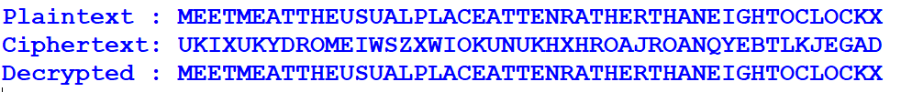
Output:

